Appendix C

Public Information of New Traffic Control Devices

1 | Name
2 | Photo
3 | Purpose and Meaning
4 | Who is affected?
5 | What should road users do when they see this sign?
6 | Where should road users expect to see this sign?
7 | How does this sign apply to the rules of the road?
8 | Other Information

Wind Gust Sign

1 | Name
Wind Gust Sign
2 | Photo
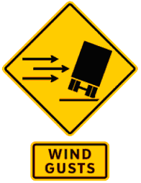
3 | Purpose and Meaning
The Wind Gust Sign is to warn truck drivers of strong winds or wind gusts that may cause the driver to lose control of their vehicle. The direction of the arrow on the sign indicates which direction the truck may tip from wind gusts.
4 | Who is affected?
This sign is aimed at truck drivers.
5 | What should road users do when they see this sign?
Truck drivers who see this sign should be aware that wind gusts are common in the area and should adapt their driving accordingly.
6 | Where should road users expect to see this sign?
Road users should expect to see this sign in stretches of road that are prone to wind gusts.
7 | How does this sign apply to the rules of the road?
This sign is a warning sign. Therefore it does not obligate drivers to alter their driving habits. It only serves to warn drivers of a potential risk.
8 | Other Information
Educational tab “wind gusts” may be used along with the warning sign.

